**WEEK-2**

**Exercise 1: Logging Error Messages and Warning Levels**

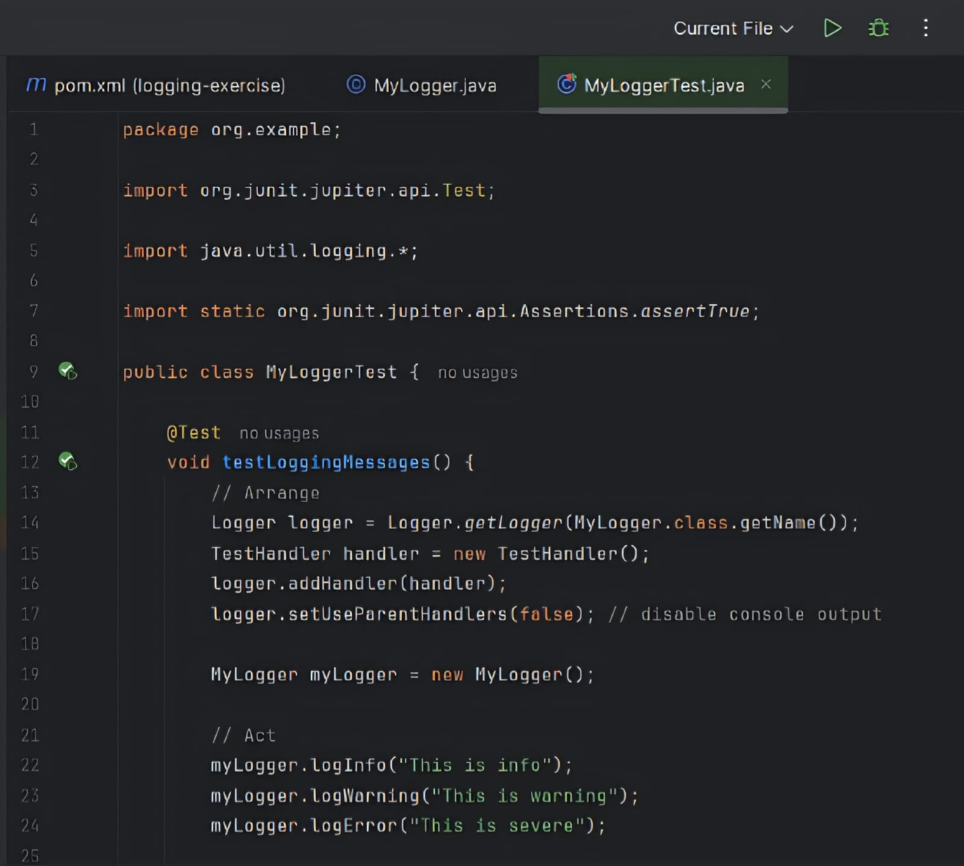

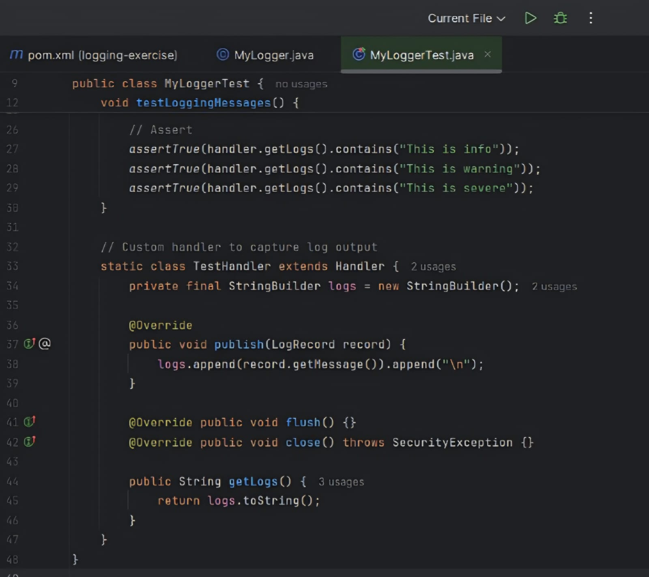

OUTPUT:

